A1338-AM,S-Peru-Chancay-Textile with Feline Heads-1000-1470 CE

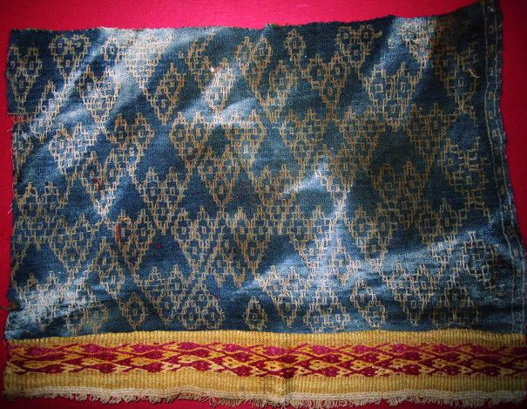

Fig. 1. Peru-Chancay-Textile with Feline Heads-1000-1470 CE

**Case no.: 7**

**Accession Number: A1338**

**Formal Label:** Peru-Chancay-Textile with Feline Heads-1000-1470 CE

**Display Description:**

This Chancay polychrome textile fragment is from the central coastal desert valleys of the Chancay, Chillon, Rimac and Lurin Rivers.

**LC Classification:** F3429.1 C47

**Date or Time Horizon:** 1200 and 1470 C

**Geographical Area:** valleys of Chancay, Chillon, Rimac and Lurin, on the central coast of Peru

**Map, GPS coordinates:**

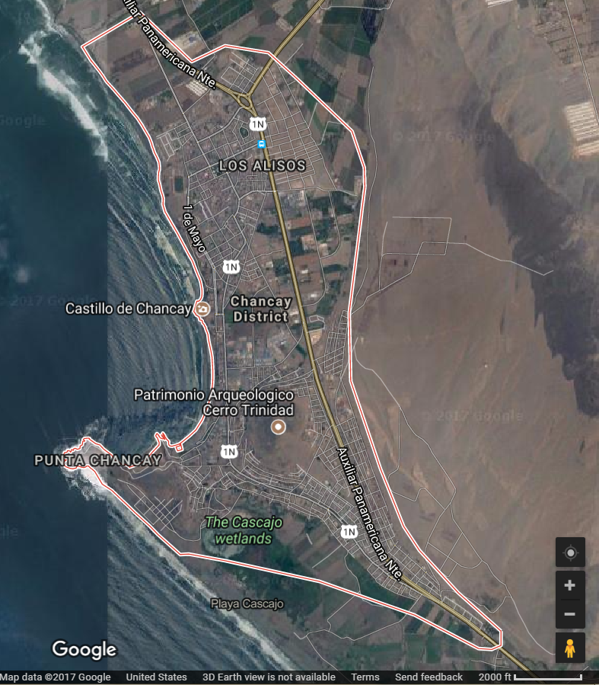

**Fig. 2.** Chancay Culture Area, After Google.com.

**Cultural Affiliation:** Chancay

**Media:** alpaca wool dyed yellow and red; wool dyed blue and cream.

**Dimensions:** H 9 in W 12 in.

**Weight:**

**Condition: Original**

**Provenance:** Peruvian collection, ca. 1950

**Discussion:** Chancay culture’s textile art was inherited from the Paracas culture (800 BCE-200 CE), which is reflected in the fabrics in which the dead were wrapped. The present textile specimen incorporates a serpentine motif in both the red and gold border and the blue and gold ground motif. Some funerary dolls seem to evoke specific individuals who were dear to the deceased. In addition to this single individual in a hammock, the Atlantika collection has a doll with two individuals dressed in ancient Chancay apparel and wrapped in their own hammock to accompany the deceased on their afterlife journey, so multiple individuals could accompany the deceased is desired!

**References:**

Banco de Crédito del Perú. 1982. *Culturas precolombinas: Chanc*ay. Lima, Perú: Banco de Crédito del Perú.

Feltham, Jane. 1996. “Chancay.” In *The Dictionary of Art*, Jane Turner, ed. London: MacMillan: 440.

**AP: .14**